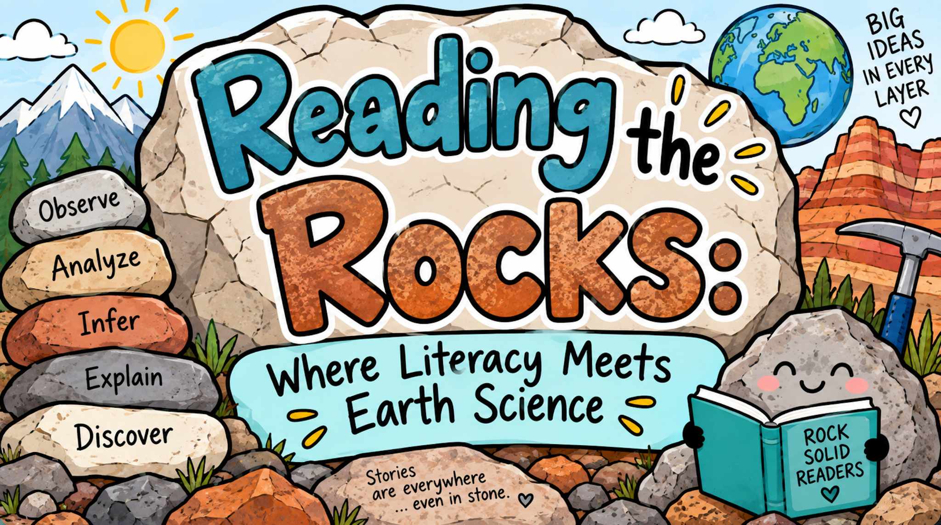
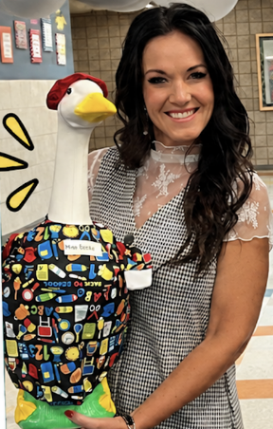

Contact the presenter: Natalie Dalton
ndalton@alpinedistrict.org

Open Sci Ed- 4th Grade Earth Processes
Link to Website (create a free account)

ASD Open Sci Ed-Earth Processes
Teacher’s Manual
Discussion Prompts

Resources from today’s presentation
Presentation Slides
Documents

